 | 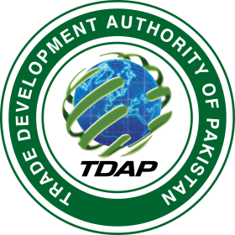
SUBJECT: DOMESTIC COMMERCE ORIENTATION & RESEARCH WORKSHOPS FOR BUSINESS COMMUNITY OF SINDH - URBAN , JOINTLY ORGANIZED BY TDAP AND MINISTRY OF COMMERCE

INVITATION

Trade Development Authority of Pakistan cordially invites you to participate in the workshop on the subject matter as per the below schedule:
Venue: Conference Room 3rd Floor, Block-A, Finance Trade Centre, Shah rah-e- Faisal, Karachi

Day-2 (26th April, 2017, Tuesday) SCHEDULE

11.00 A.M Recitation of Holy Quran

11.20 A.M Welcome address by Director General, TDAP

11.35 A.M Participants Introduction

11.35 A.M Session-I (Domestic Commerce & Economy)

1.00 A.M 30 Minutes Lunch Break

1.30 P.M Session (Potential of Pakistani Domestic Commerce)

2.30 P.M 20 Minutes Tea Break

2.50 P.M to 3.50 Session III - Role of Public & Private sector in Pakistani Domestic Commerce.

Please make sure your presence in the above mentioned important event, as it is exclusively organized for the business community.

For further information please contact:

- Mr. Asif Raza Somoro, Deputy Director, TDAP, Karachi. Cell 0310-2671404
- Mr. Hamid Shahinshah,Assistant Director, TDAP, Karachi. Cell 0300-2472443.

